CS-1 (2016-2019) Programming Board Questions

Q) WAP in C++ to print first 20 terms of Fibonacci Series (Series is 0,1,1,2,3,5,8….)

Q) Implement a class temperature. Include a constructor in it which accepts value of temperature from user in degree Celsius. Include two Fn in it, one of which calculates its equivalent temperature in degree Fahrenheit and other functions prints the answer:

$$\frac{C}{5}=\frac{F-32}{9}$$

Q) Implement a class avg. Include a constructor in it which will accept value of three variables from user. Include two more functions in it, one function calculates average and other prints it.

Q)

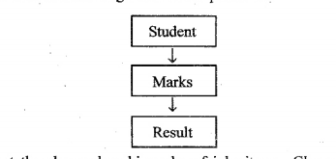

Implement the above class hierarchy of inheritance. Class student accepts roll no. of student, class marks accepts marks of three subjects and class result calculates the total and print all details. (Create obj of class result).

Q)

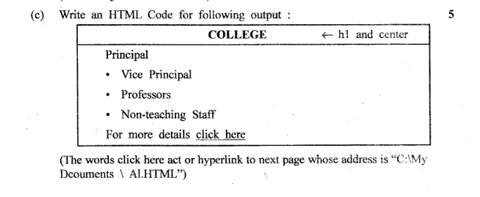

Q)

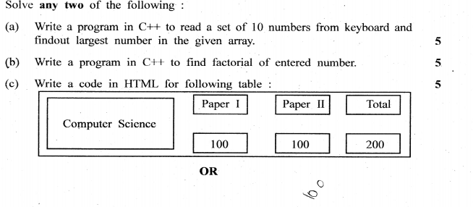

Q)

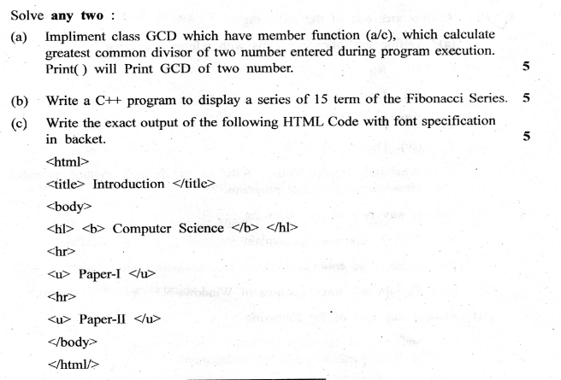

Q)

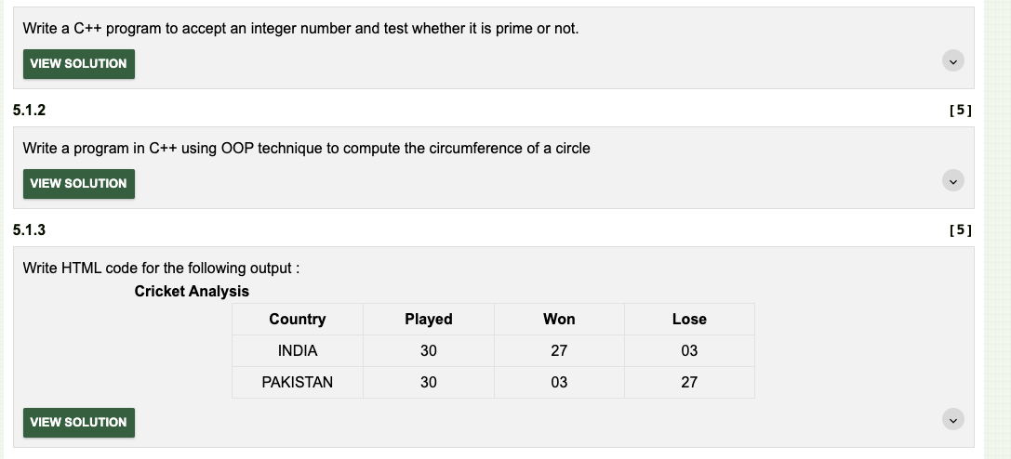

Q)

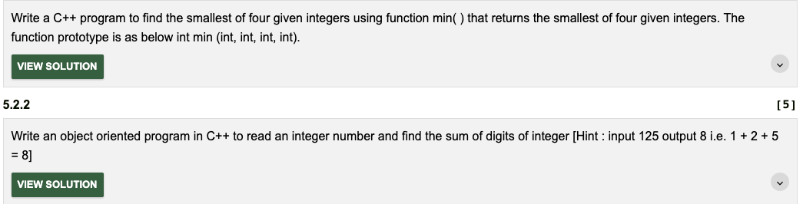

Q)

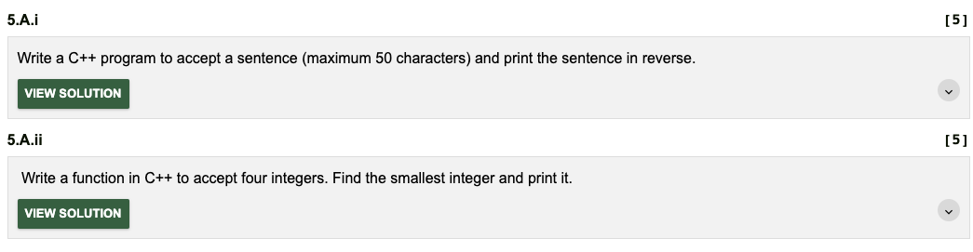

Q)

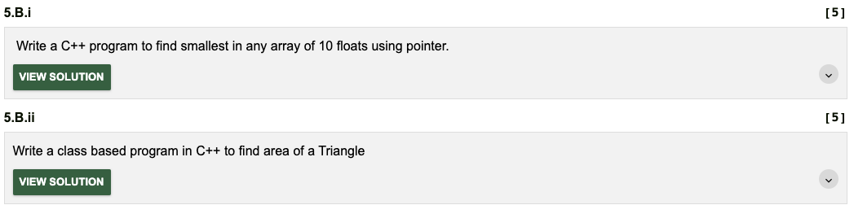

Q)

